**BASH SCRIPTING**

* 1) Write a shell script to run the following operations by reading 2 numbers and one choice from the user:
  + Addition
  + Subtraction
  + Multiplication
  + Division
  + Average

It should be a choice based program i.e. if the input is 1, Addition should be performed.

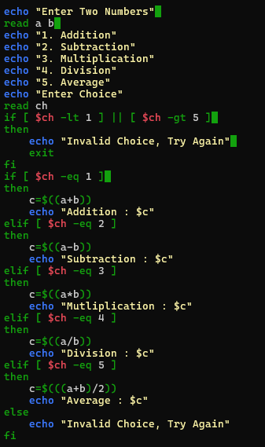

OUTPUT :

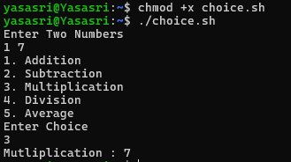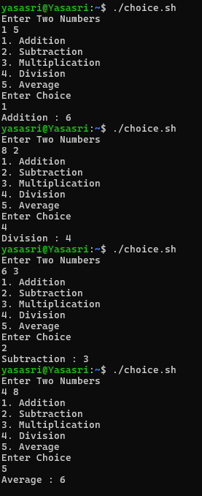

* 2) Write a shell script to check whether a number is a palindrome or not.

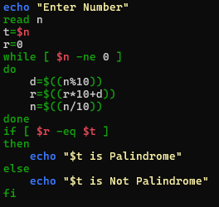

OUTPUT :

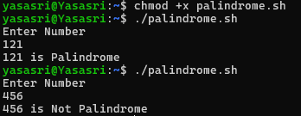

* 3) Write a script to run the following operations by reading an input and a choice from the user:
  + ROT13 Encode
  + ROT13 Decode

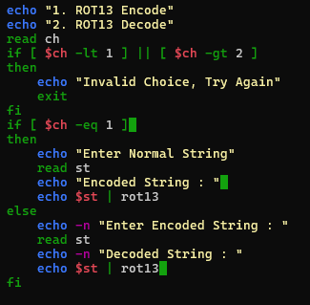

OUTPUT :

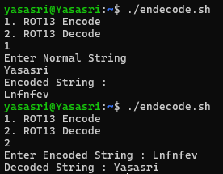

* 4) Using functions, write a shell script program to check whether a file named “persistence” is present in your system.

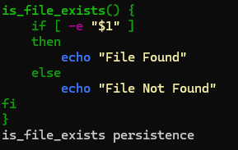

OUTPUT :

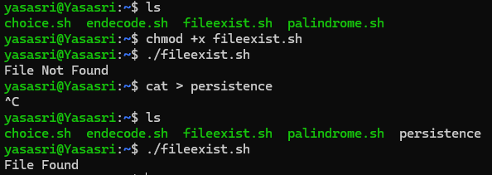

1111te a shell script to run the following operations by reading 2 numbers and one choice from the user:

* + Addition
  + Subtraction
  + Multiplication
  + Division
  + Average

It should be a choice based program i.e. if the input is 1, Addition should be performed